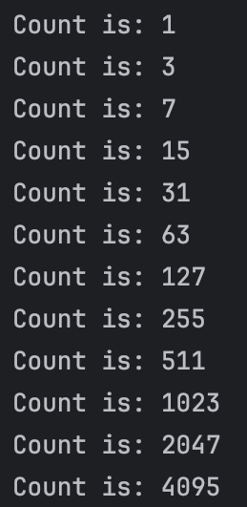

Program 1 starts by creating a for loop, using an integer variable named i starting at 1 and stopping before it reaches 5000 or higher. It continues to iterate variable i, multiplying the current total by two and adding 1 each time, keeping a running total during the entire for loop. The for loop stops at the last number i equals before i would be equal to or greater than 5000. The programs output will display each value of i for each iteration of the for loop. The loop will display the data by stating the “Count is:” and then the current value of i.